

Name: Sajjal Tariq
Roll No: 10011
Section: A
Submitted To: Sir Zohaib Khan

LAB NO 4
Inserting data, Deleting data and Modifying data

To study the various data manipulation language commands and
implement them on the database

Instructions
▪ This is individual Lab work/task.
▪ Complete this lab work within lab timing.
▪ Discussion with peers is not allowed.
▪ You can consult any book, notes &amp; Internet.
▪ Copy-pasting from Internet will give you negative marks.
▪ Lab work is divided into small tasks; complete all tasks sequentially.
▪ Show solution of each lab task to your Lab Instructor.
▪ Paste your solution (i.e. code) in given space under each task.
▪ Also make a zip/rar archive of all lab tasks and upload this file on LMS before
leaving lab.
▪ In-Lab Exercises/Tasks

FACILITIES REQUIRED AND PROCEDURE
Facilities required to do the experiment

S.No
Facilities Required Quantity
1 System 1
2 Operating System Windows 10
3 Front End Java
4 Back End Oracle 11g, MySQL

Procedure for doing the experiment
Step Detail
1 DML Commands

DML commands are the most frequently used SQL commands and is
used to query and manipulate the existing database objects. DML
statements are used for managing data in database. DML commands
are not auto-committed. It means changes made by DML command
are not permanent to database, it can be rolled back.
Some of the commands are:
Select
Insert
Update
Delete

4 Update Command
It is used to alter the column values in a table. A single column may be
updated or more than one column could be updated.
5 Delete Command

After inserting row in a table we can also delete them if required. The
delete command consists of from clause followed by an optional
where clause.

SQL COMMANDS
Update Command
Syntax: update tablename set field=values where condition;
Example:Update emp set sal = 10000 where empno=135;

Delete Command
Syntax: delete from table where conditions;
Example: delete from emp where empno=135;

Tasks
Q1: Update the emp table to set the salary of all worker to Rs15000/- who are
working as ASP
Answer:
SQL> CREATE TABLE worker (
2 personno NUMBER,
3 name VARCHAR2(20),
4 job VARCHAR2(20),
5 deptno NUMBER,
6 sal NUMBER
7 );
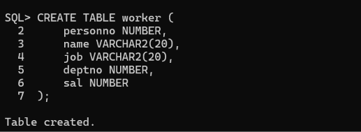
Values Insertion:

SQL> INSERT INTO worker VALUES (1, 'Sajal', 'AP', 1, 11000);
SQL> INSERT INTO worker VALUES (2, 'Zohaib', 'ASP', 2, 12500);
SQL> INSERT INTO worker VALUES (3, 'Hasnain', 'ASP', 1, 13000);
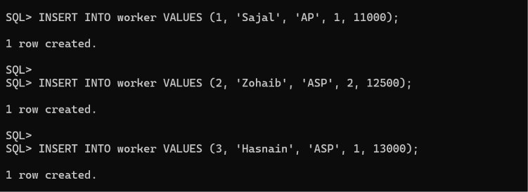
Data Confirmation:
SQL> SELECT * FROM worker;
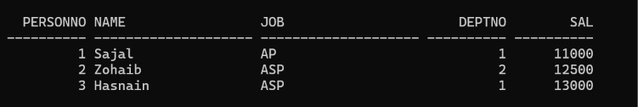
Update Rows:
UPDATE worker SET sal = 15000 WHERE job = 'ASP';
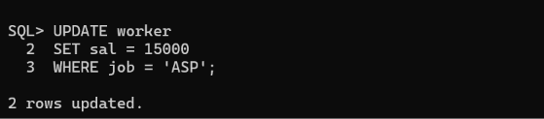
Final Table:
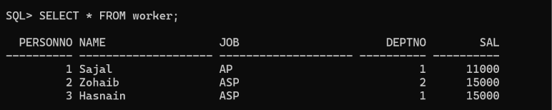
Q2: Create a pseudo (copy) table worker_copy with the same structure as the table person and insert rows into the table using the SELECT clause. Answer:
Answer:
SQL> CREATE TABLE employee AS SELECT * FROM worker;
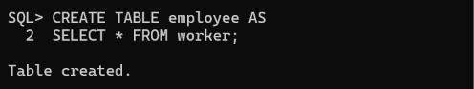
SQL> DESC employee;
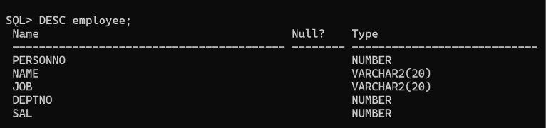
SQL> SELECT * FROM employee;
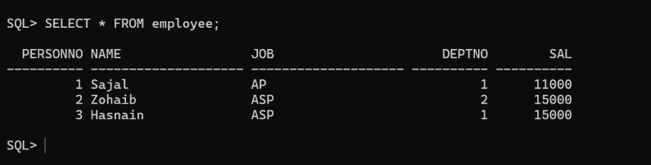
Q3: Select employee name and job from the emp table;
Answer:
Select name or job:
SELECT name, job FROM worker;


Q4: Delete only those who are working as a lecturer.
Answer:
DELETE FROM worker
WHERE job = 'Lecturer';

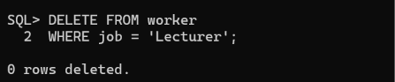

Q5: List the records in the emp table ordered by salary in ascending order.
Answer:
SQL> SELECT * FROM worker
2 ORDER BY sal;
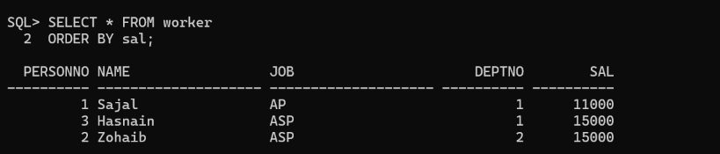
Q6: List the records in the emp table order by salary in descending order.
Answer:
SQL> SELECT * FROM worker
2 ORDER BY sal DESC;
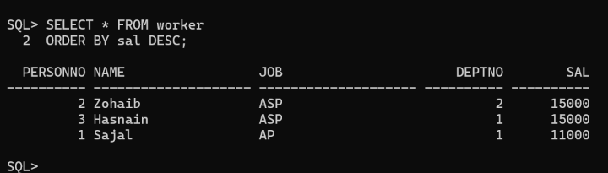

OUTCOME
Thus the DML commands using from where clause was performed successfully and
executed.
Extra Task:

QUESTIONS AND ANSWERS
What is DML?
DML commands are the most frequently used SQL commands and is used to query and
manipulate the existing database objects.

What are DML command?
Some of the commands are Insert, Select, Update and Delete
Give the general form of SQL Queries?
Select A1, A2............., An
From R,1R2..............., Rm
Where P

How to rename the Table?
Rename command is used for renaming the table as:

Rename &lt;Table1&gt; To &lt;Table2&gt;
If where clause is not used in the delete statement then what will happen with the
Table?
If where clause is not used in the delete statement then all of the records in the Table
will be deleted after executing the query
Write the syntax to retrieve specific columns from a table:
Syntax: Select column_name1,column_name2, …, column_nameN from Table_name;

